Contents

1.1 Introduction 2

1.2 Organization of Report 2

1.3 Study Area 2

1.4 System Elements 2

1.4.1 Sources 2

1.4.2 Tank 2

1.4.3 Nodes and Pipes 2

1.4.4 Pumps 3

1.4.5 Wells 3

1.4.6 Valves 3

1.4.7 Emergency Supply 3

1.4.8 Fire Hydrants 3

1.5 Demand 3

1.6 Conclusion 3

1.7 Tables 4

1.8 Figures 9

# 1.1 Introduction

The process of building a hydraulic model requires the collection of a lot of data. To identify what data is necessary to begin the process, a system overview is necessary to identify its elements and demand. The purpose of this report is to inform our professor and classmates what data has been collected and what data is still in the process of collection and to summarizes how the demand was distributed and calculated.

# 1.2 Organization of Report

Report is divided in a way to illustrate the system and all its elements, demand assignment and its calculation, design criteria to be used and limitations of the data and information collected from our administrator.

# 1.3 Study Area

Copperton is a [CDP](https://en.wikipedia.org/wiki/Census-designated_place) (census-designated place) and [township](https://en.wikipedia.org/wiki/Township_(United_States)) situated in [Salt Lake County](https://en.wikipedia.org/wiki/Salt_Lake_County,_Utah), Utah, [United State](https://en.wikipedia.org/wiki/United_States). It is located at the mouth of [Bingham Canyon](https://en.wikipedia.org/wiki/Bingham_Canyon), about 17 miles southwest of [Salt Lake City](https://en.wikipedia.org/wiki/Salt_Lake_City). This township was established in 1926, by the [Utah Copper Company](https://en.wikipedia.org/wiki/Utah_Copper_Company) as a residential area for its employees. According to the 2010 Census, Copperton has a population of 826. Copperton is the only mining town remaining for the [Bingham Canyon Mine](https://en.wikipedia.org/wiki/Bingham_Canyon_Mine) after Lark was torn down in 1980. Currently, only a handful of residents work for the mine.

# 1.4 System Elements

The Copperton Improvement District water supply system comprises of two wells and one storage tank. The whole system is gravity-fed. The layout of pipe network has been shown in **Figure 1**.  Our administrator supplied this layout.

## 1.4.1 Sources

The main sources of this water supply system are two wells with the capacity of 300 and 600 gpm respectively; it supplies one tank that supplies the whole system.

## 1.4.2 Tank

The storage tank is ground buried concrete tank with a capacity of one million gallons. The tank is operated in such a way that its maximum and minimum elevations are kept as 15 ft and 13 ft respectively. We have requested the dimensions of the tank from our administrator.  The elevation of the tank is 5672 ft.

## 1.4.3 Nodes and Pipes

The system comprises of 46 pipes that were originally made of cast iron. According to the report from Sunrise Engineering, all pipes were replaced for PVC C900 in 2002 except for one. All pipes have 10 inch diameter. These two pieces of information came directly from our system administrator. The lengths of the pipes were calculated using Google earth and confirmed using the scale in the maps provided by our system administrator. The elevation of the nodes will be obtained on site when the field tests are performed. Information for the pipes has been provided in Table-1.

## 1.4.4 Pumps

There are two pumps in the system, one for each well. The information on pump curves has been requested. Soon after finding the information, it will be incorporated in the model.

## 1.4.5 Wells

There are two wells (Well #2 and Well #3) that have a capacity of 300 and 600 gpm respectively. The information of the water levels has also been requested.

## 1.4.6 Valves

There are no valves of importance in the system; the only ones present are check valves.

## 1.4.7 Emergency Supply

There is one emergency connection to the Jordan Valley District. According to the system administrator, this connection has never been required to use. We don’t believe it to be necessary to add this connection to the model.

## 1.4.8 Fire Hydrants

The locations of the fire hydrants are provided in the system map **Figure 1**, it is presented as a solid circular symbol.

## 1.5 Demand

The Copperton Improvement District water supply system provides supply to 304 connections (17 commercial and 286 residential).  The administrator provided a summary of billing data for the 2015 year; this information is given in Table 2.

Additionally, the billing data indicated that there was one user who used in excess of 750,000 gallons per month four times throughout the year.  It was inquired from our administrator as to where this user is within the system, as that will affect our model.

Demands were applied to nodes placed at pipe intersections using even distribution **Figure 2**. According to our system administrator, unaccounted for water makes up 20% of the total water used in the system.  This water is believed to be leaking mostly at the tank and at Copperton Circle, where the cast iron pipe still remains.  These losses will be applied at nodes evenly within Copperton Circle and near the storage tank.  Demand information at each node is provided in Table 3. The method used to calculate demand was dividing the average monthly usage to the number of accounts in the system. This will be changed once we have identified our heavy user.

## 1.6 Conclusion

Our team believes we have enough information to start building the hydraulic model. This information includes the number of sources, the number of tanks, pipe diameter, pipe material, pipe age, number of nodes, location of nodes and distribution of demand. The data that will be used to start the process has been provided in the tables. An e-mail requesting all the data missing has been prepared and will be sent to our system administrator. He said he would have all the data available for us on Friday march 18, when we go do our field tests. Once the information on pumps curves, well water levels and major water users is obtained, the Copperton hydraulic model can be completed and the process of calibration will begin.

# 1.7 Tables

*Table 1 - Pipe Data*

|  |  |  |  |  |
| --- | --- | --- | --- | --- |
| **Pipe Number** | **Length (ft)** | **Material** | **Diameter (in)** | **C Value** |
| P1 | 230 | PVC | 10 | 150 |
| P2 | 388 | PVC | 10 | 150 |
| P3 | 284 | PVC | 10 | 150 |
| P4 | 434 | PVC | 10 | 150 |
| P5 | 413 | PVC | 10 | 150 |
| P6 | 294 | PVC | 10 | 150 |
| P7 | 289 | PVC | 10 | 150 |
| P8 | 359 | PVC | 10 | 150 |
| P9 | 406 | PVC | 10 | 150 |
| P10 | 291 | PVC | 10 | 150 |
| P11 | 401 | PVC | 10 | 150 |
| P12 | 384 | PVC | 10 | 150 |
| P13 | 447 | PVC | 10 | 150 |
| P14 | 446 | PVC | 10 | 150 |
| P15 | 380 | PVC | 10 | 150 |
| P16 | 406 | PVC | 10 | 150 |
| P17 | 295 | PVC | 10 | 150 |
| P18 | 627 | Cast Iron | 10 | 75 |
| P19 | 290 | PVC | 10 | 150 |
| P20 | 276 | PVC | 10 | 150 |
| P21 | 569 | PVC | 10 | 150 |
| P22 | 282 | PVC | 10 | 150 |
| P23 | 281 | PVC | 10 | 150 |
| P24 | 311 | PVC | 10 | 150 |
| P25 | 293 | PVC | 10 | 150 |
| P26 | 288 | PVC | 10 | 150 |
| P27 | 416 | PVC | 10 | 150 |
| P28 | 292 | PVC | 10 | 150 |
| P29 | 417 | PVC | 10 | 150 |
| P30 | 317 | PVC | 10 | 150 |
| P31 | 334 | PVC | 10 | 150 |
| P32 | 394 | PVC | 10 | 150 |
| P33 | 262 | PVC | 10 | 150 |
| P34 | 398 | PVC | 10 | 150 |
| P35 | 271 | PVC | 10 | 150 |
| P36 | 404 | PVC | 10 | 150 |
| P37 | 588 | PVC | 10 | 150 |
| P38 | 305 | PVC | 10 | 150 |
| P39 | 411 | PVC | 10 | 150 |
| P40 | 294 | PVC | 10 | 150 |
| P41 | 268 | PVC | 10 | 150 |
| P42 | 421 | PVC | 10 | 150 |
| P43 | 292 | PVC | 10 | 150 |
| P44 | 371 | PVC | 10 | 150 |
| P45 | 444 | PVC | 10 | 150 |
| P46 | 285 | PVC | 10 | 150 |

*Table 2 - Billing Data*

|  |  |  |  |  |  |  |  |
| --- | --- | --- | --- | --- | --- | --- | --- |
| Month | Gallons Used (1000s) | Total Accounts | Residential Accounts | Commercial Accounts | Average Residential Usage | Average Commercial Usage | Read or Estimated |
| December | - | 303 | 285 | 18 | - | - | Estimated |
| November | - | 304 | 287 | 17 | - | - | Estimated |
| October | 3,040 | 304 | 287 | 17 | 8.05 | 42.88 | Read |
| September | 6,794 | 304 | 288 | 16 | 17.10 | 116.88 | Read |
| August | 8,216 | 304 | 288 | 16 | 21.48 | 126.81 | Read |
| July | 9,238 | 304 | 288 | 16 | 23.13 | 161.12 | Read |
| June | 2,086 | 301 | 285 | 16 | 5.43 | 33.69 | Read |
| May | 2,086 | 301 | 285 | 16 | 5.43 | 33.69 | Read |
| April | 4,755 | 303 | 285 | 18 | 6.32 | 164.06 | Read |
| March | 3,779 | 304 | 285 | 19 | 8.20 | 75.89 | Read |
| February | - | 300 | 283 | 17 | - | - | Estimated |
| January | 5,925 | 302 | 284 | 18 | 13.82 | 111.06 | Read |
| Total | 45,919 | 3,634 | 3,430 | 204 | 109 | 866 |  |
| Avg | 3,827 | 303 | 286 | 17 | 9 | 72 |  |

*Table 3 - Node Data*

|  |  |  |  |  |
| --- | --- | --- | --- | --- |
| Node | Number of Connections | Avg Demand (gph) | Losses | Elevation |
| N1 | 6 | 139.8 | 0 |  |
| N2 | 7 | 163.1 | 0 |  |
| N3 | 13 | 302.9 | 0 |  |
| N4 | 8 | 186.4 | 0 |  |
| N5 | 12 | 279.6 | 0 |  |
| N6 | 9 | 209.7 | 0 |  |
| N7 | 12 | 279.6 | 0 |  |
| N8 | 10 | 233 | 0 |  |
| N9 | 6 | 139.8 | 0 |  |
| N10 | 12 | 279.6 | 0 |  |
| N11 | 12 | 279.6 | 0 |  |
| N12 | 4 | 93.2 | 0 |  |
| N13 | 7 | 163.1 | 0 |  |
| N14 | 7 | 163.1 | 0 |  |
| N15 | 10 | 233 |  |  |
| N16 | 13 | 302.9 |  |  |
| N17 | 17 | 396.1 | 0 |  |
| N18 | 9 | 209.7 | 0 |  |
| N19 | 6 | 139.8 | 0 |  |
| N20 | 6 | 139.8 | 0 |  |
| N21 | 10 | 233 | 0 |  |
| N22 | 6 | 139.8 | 0 |  |
| N23 | 4 | 93.2 | 0 |  |
| N24 | 7 | 163.1 | 0 |  |
| N25 | 10 | 233 | 0 |  |
| N26 | 10 | 233 | 0 |  |
| N27 | 7 | 163.1 | 0 |  |
| N28 | 12 | 279.6 | 0 |  |
| N29 | 9 | 209.7 | 0 |  |
| N30 | 10 | 233 | 0 |  |
| N31 | 6 | 139.8 | 0 |  |
| N32 | 9 | 209.7 | 0 |  |
| N33 | 17 | 396.1 | 0 |  |
| N34 | 11 | 256.3 | 0 |  |

# 1.8 Figures

*Figure 1 – Layout of pipes in system and hydrant locations*

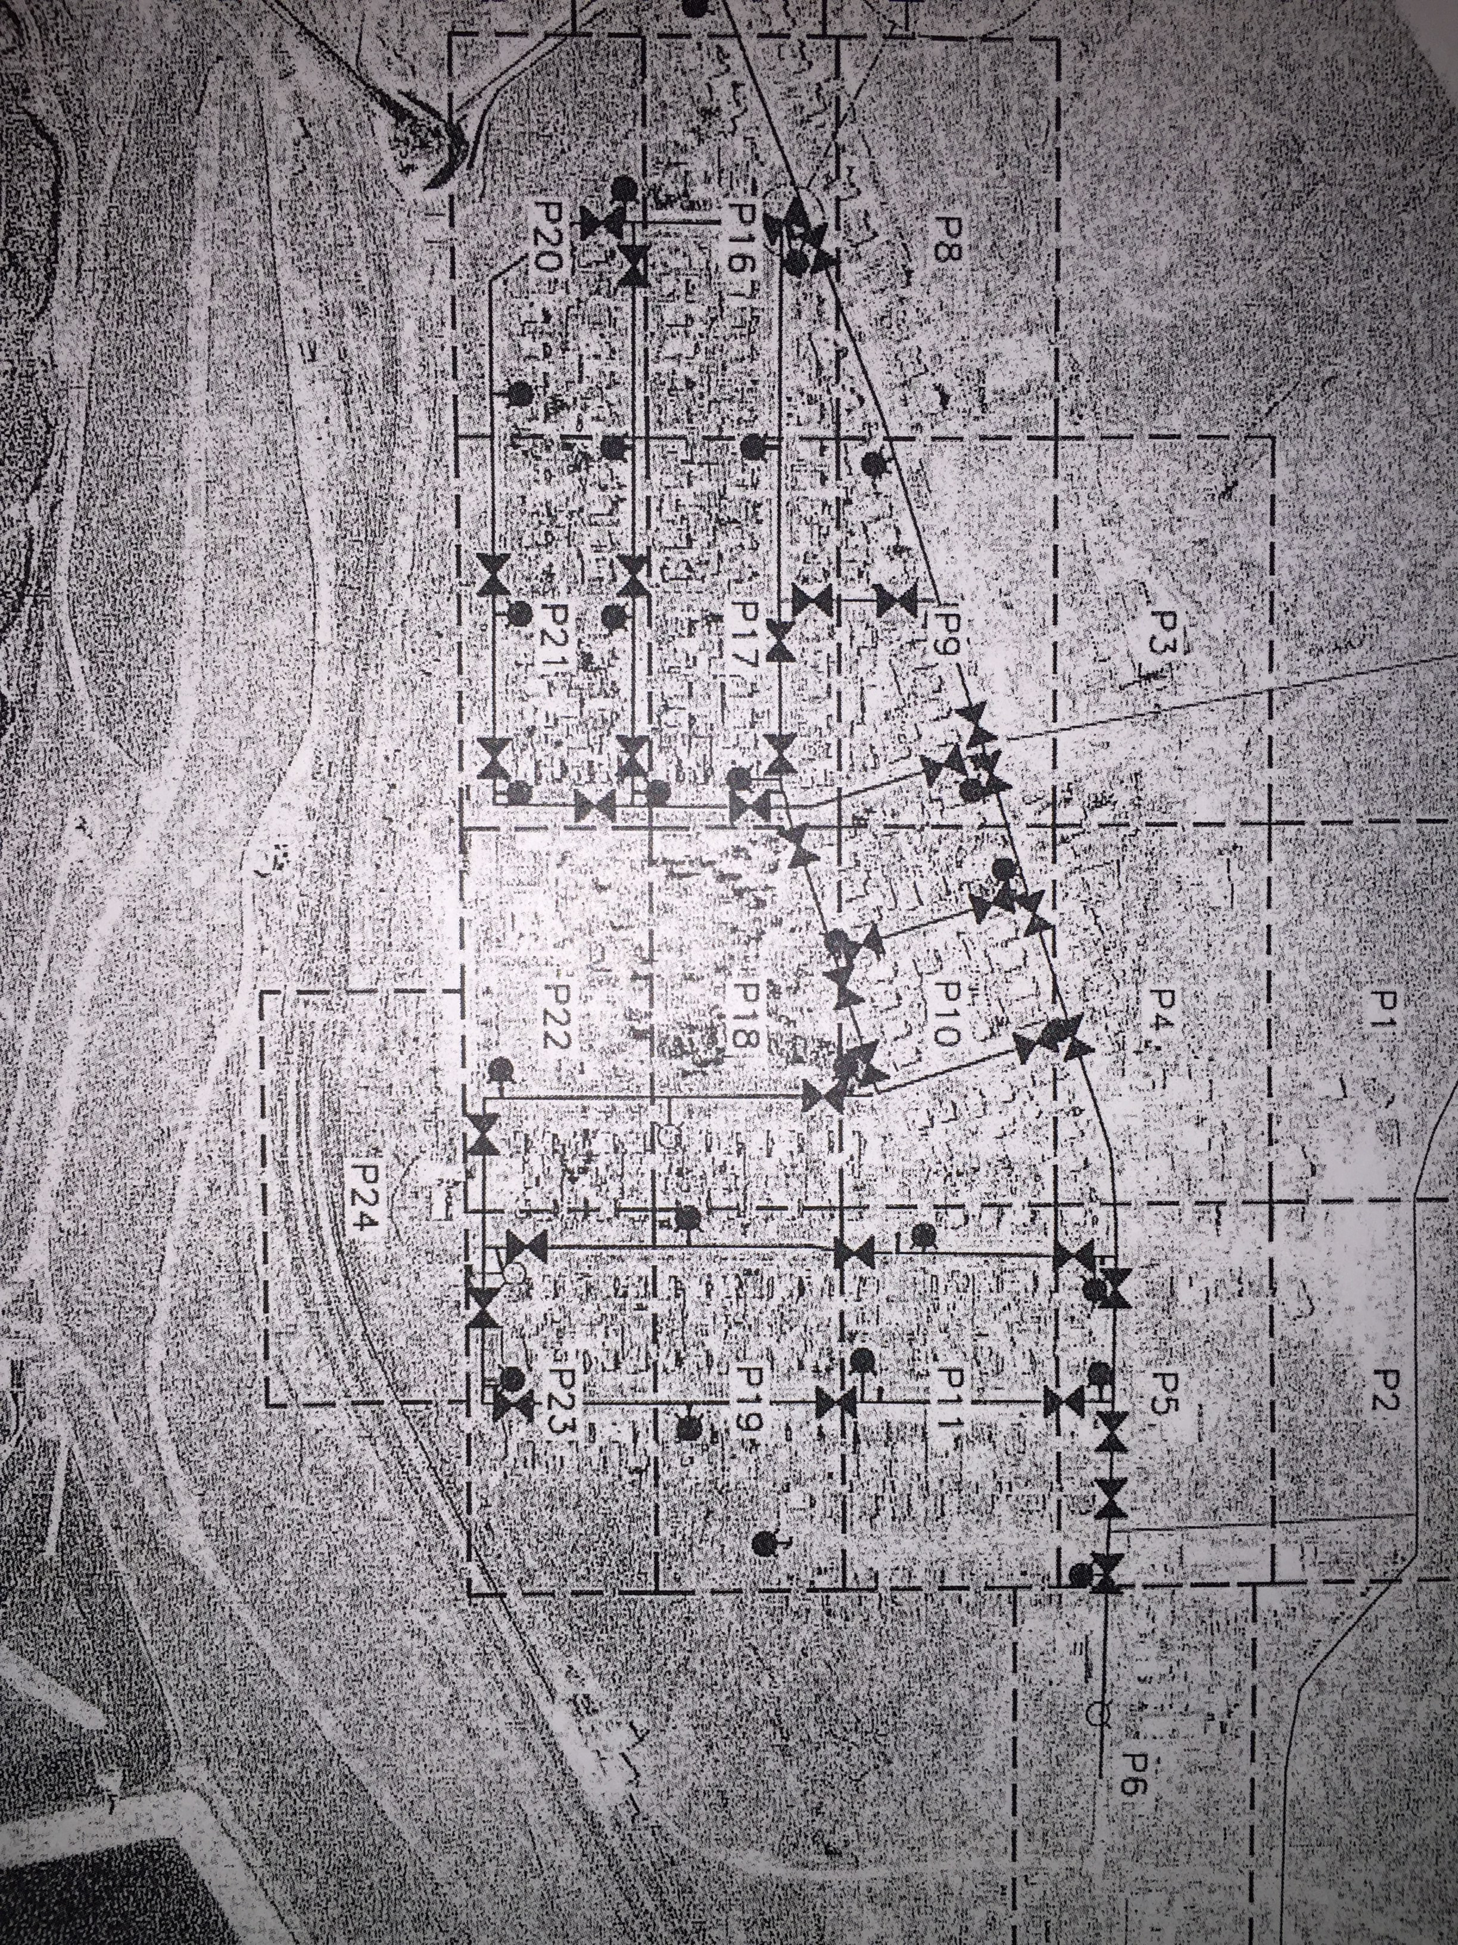

*Figure 2 – Node number assignment, pipe number assignment and demand distribution